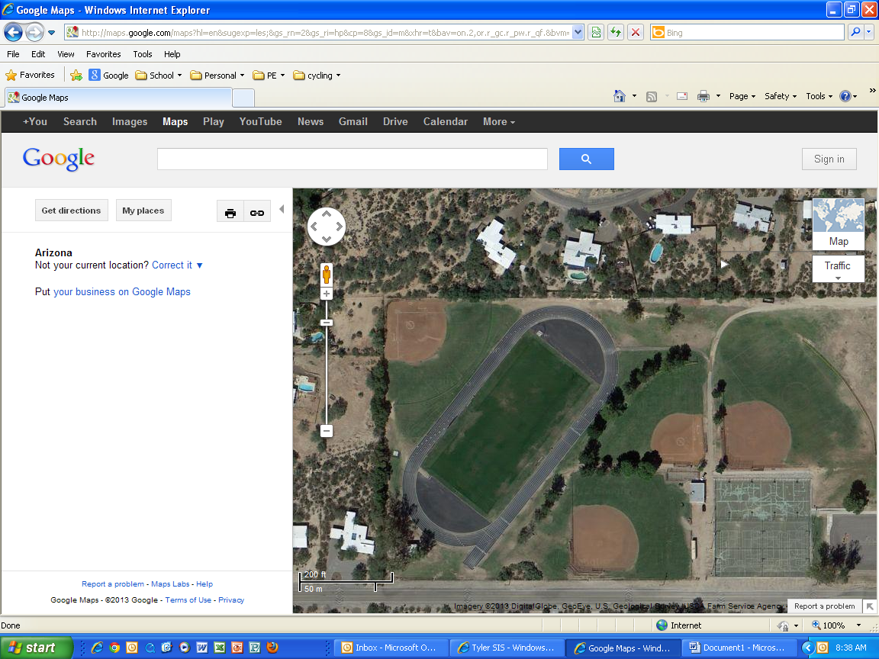

When a student is absent or unable to complete a Fitness RUN for any reason, he/she will need to complete a make-up RUN. This is done by either completing the make-up RUN during a time designated by the teacher or on their own time. The course is laid out as depicted by the picture above. It is a 1.5 mile course that can be run in both direction and starting from any point on the course.

In order to be considered complete, please do the following:
- Parents walk one lap with your child so you understand the EXACT course.
- Determine the starting location and use a stop-watch to time the run.
- Runner will need to complete FOUR complete laps from the starting location without cutting any part of the course.
- Parents will need to print their name on this sheet acknowledging they witnessed the student run the Fitness RUN course exactly and this is their legitimate time.

Student name_______________________ Parent Name_________________________
(Printed) (Printed)

RUN Time: __________________ Parent Email: ______________________________

Parent Phone Number: _____________________________
* NOTE to Parents: By signing this paper, you are acknowledging you witnessed your child run the Fitness Run in the time posted above.

